**TEAM ID: PNT2022TMID26285**

**AI-based localization and classification of skin disease with erythema**

**1.INTRODUCTION**

**1.1 Project Overview:**

Now a day’s people are suffering from skin diseases, More than 125 million people suffering from Psoriasis also skin cancer rate is rapidly increasing over the last few decades especially Melanoma is most diversifying skin cancer. If skin diseases are not treated at an earlier stage, then it may lead to complications in the body including spreading of the infection from one individual to the other. The skin diseases can be prevented by investigating the infected region at an early stage. The characteristic of the skin images is diversified so that it is a challenging job to devise an efficient and robust algorithm for automatic detection of skin disease and its severity. Skin tone and skin colour play an important role in skin disease detection. Colour and coarseness of skin are visually different. Automatic processing of such images for skin analysis requires quantitative discriminator to differentiate the diseases.

To overcome the above problem we are building a model which is used for the prevention and early detection of skin cancer, psoriasis. Basically, skin disease diagnosis depends on the different characteristics like colour, shape, texture etc. Here the person can capture the images of skin and then the image will be sent the trained model. The model analyses the image and detect whether the person is having skin disease or not.

**1.2 Purpose:**

We classify each cluster into different common skin diseases using another neural network model. Our segmentation model achieves better performance compared to previous studies, and also achieves a near-perfect sensitivity score in unfavorable conditions. Our classification model is more accurate than a baseline model trained without segmentation, while also being able to classify multiple diseases within a single image. This improved performance may be sufficient to use CAD in the field of dermatology.

**2.LITERATURE SURVEY**

**2.1 Existing Problem:**

An inherent disadvantage of clustering a skin disease is its lack of robustness against noise. Clustering algorithms rely on the identification of a centroid that can generalize a cluster of data. Noisy data, or the presence of outliers, can significantly degrade the performance of these algorithms. Therefore, with noisy datasets, caused by images with different types of lighting, non-clustering algorithms may be preferred. Owing to the disadvantages of these traditional approaches, convolution neural networks (CNNs) have gained popularity because of their ability to extract high-level features with minimal preprocessing. By learning to accurately create a higher-resolution image, CNNs can determine the location of the targets to segment.

**2.2 References:**

Doi, K. Computer-aided diagnosis in medical imaging: Historical review, current status and future potential. Comput. Med. Imaging Graph.

Yoshida, H. & Dachman, A. H. Computer-aided diagnosis for CT colonography. Semin. Ultrasound CT MRI

Trabelsi, O., Tlig, L., Sayadi, M. & Fnaiech, F., Skin disease analysis and tracking based on image segmentation. 2013 International Conference on Electrical Engineering and Software Applications, Hammamet, 1–7.'

Rajab, M. I., Woolfson, M. S. & Morgan, S. P. Application of region-based segmentation and neural network edge detection to skin lesions. Comput. Med. Imaging Graph. 28, 61–68.

**2.3 Problem Statement Definition:**

Create a problem statement to understand your customer's point of view. The Customer Problem Statement template helps you focus on what matters to create experiences people will love.

A well-articulated customer problem statement allows you and your team to find the ideal solution for the challenges your customers face. Throughout the process, you’ll also be able to empathize with your customers, which helps you better understand how they perceive your product or service.

**3. IDEATION AND PROPOSED SOLUTION**

**3.1 Empathy Map canvas:**

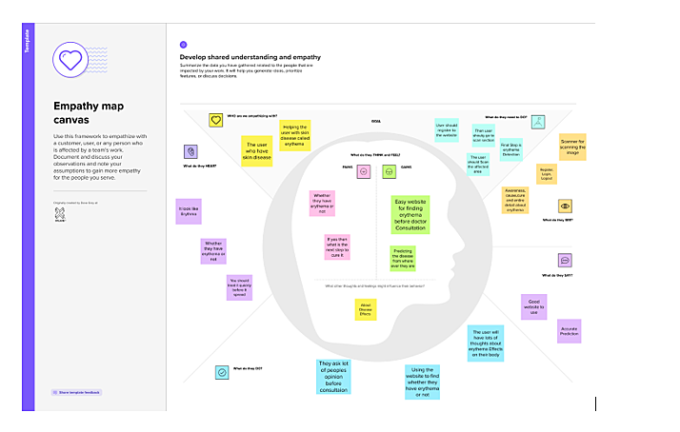

**3.2 Ideation and Brainstroming:**

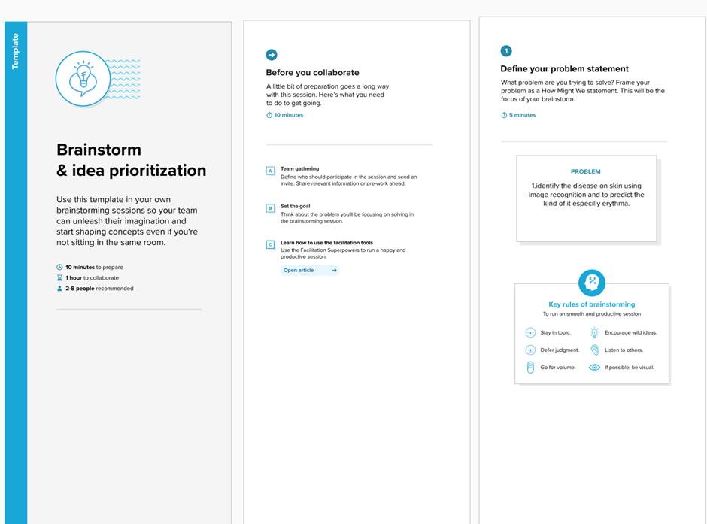

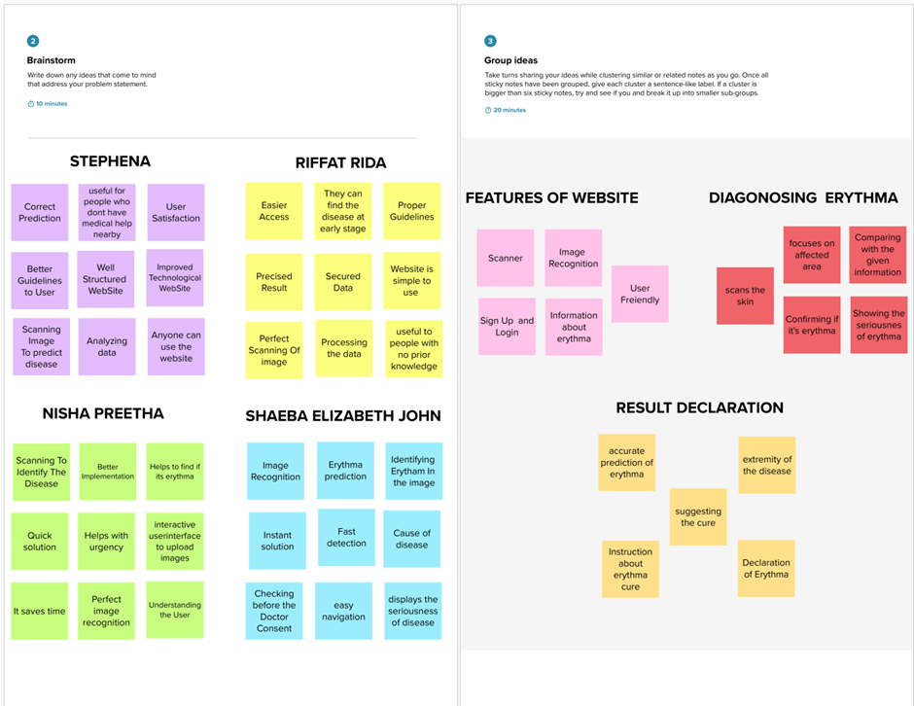

**3.3 Proposed solution:**

|  |  |  |
| --- | --- | --- |
| **S.No.** | **Parameter** | **Description** |
|  | Problem Statement (Problem to be solved) | Erythema is redness of the skin caused by injury or another inflammation-causing condition. Often presenting as a rash, erythema can be caused by environmental factors, infection, or overexposure to the sun, early detection alongwith proper medication can significantly improvesymptoms and quality of life. |
| 2. | Idea / Solution description | In This project,we are using Artificial Intelligence(AI) domain to detect the skin disease by scanning the affected area and identifying the kind of erythema. |
| 3. | Novelty / Uniqueness | Here we use YOLO algorithm which divides the image into N grids, each having an equal dimensional region of SxS.Each of these N grids is responsible for the detection and localization of the object it contains using packages like SKYKIT,NUMPY. |
| 4. | Social Impact / Customer Satisfaction | Persistent erythema associated with may negatively impact quality of life (QoL), self-esteem, and self-confidence. We evaluated burden and health-related QoL (HRQoL) impacts of centrofacial erythema.Centrofacial erythema represents a substantial HRQoL burden, especially for those with more severe erythema. |
| 5. | Business Model (Revenue Model) | Early detection with proper medication can significantly improve symtoms and quality of life.Our model can be used in hospitals to detect erythema in early stages and cure it. |
| 6. | Scalability of the Solution | scalability in our project is achieved by using deep learning module which imports the advanced packages and detects the disease by scanning the image region-wise,hence our project allows alteration in accordance with various paramaters of erythema |

**3.4 Proposed solution Fit:**

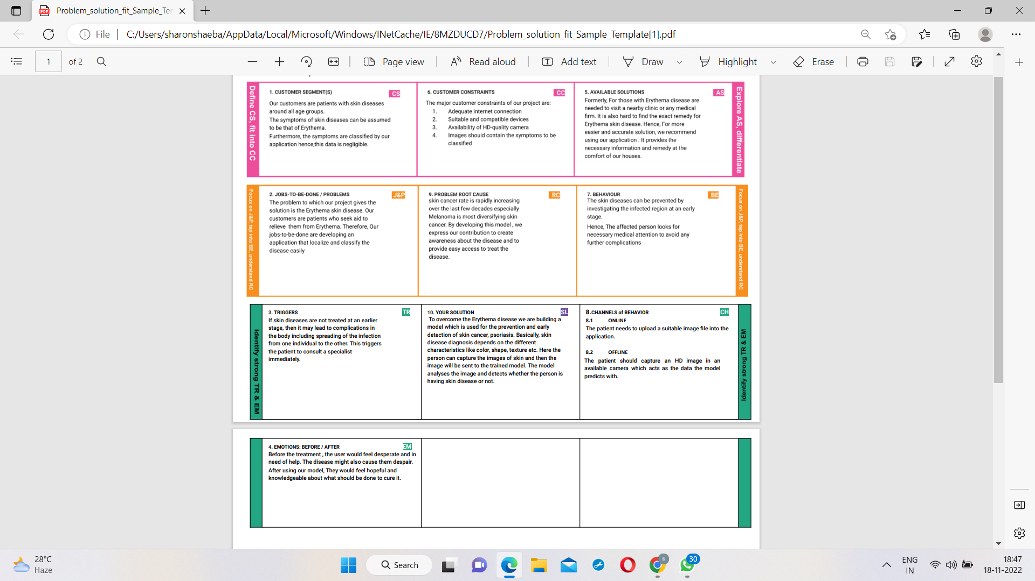**4.REQUIREMENTS ANALYSIS**

**4.1 Functional requirements**:

|  |  |  |
| --- | --- | --- |
| **FR No.** | **Functional Requirement (Epic)** | **Sub Requirement (Story/ Sub-Task)** |
| FR-1 | User Registration | Registration through mail Registration throughMobile Number |
| FR-2 | User Confirmation | Confirmation viaEmail  Confirmation via OTP |
| FR-3 | User Verification | Verification through CAPTCHA Verification throughI’m not a robot. |
| FR-4 | User Authentication | Recognition of correct personResending the codein  case of forgot password. |
| FR-5 | User skin detection | scanning user's skin using YOLO and and a proper scanner and finding the kind of erythema the patient is affected by. |
| FR-6 | User Submission | submitting the user details and scanned skin to the website to detect and provide the concerned solution. |

**4.2 Non-Functional Requirements:**

|  |  |  |
| --- | --- | --- |
| **FR No.** | **Non-FunctionalRequirement** | **Description** |
| NFR-1 | **Usability** | YOLO algorithm (You Only Look Once) is used to detect the user affected skin region -wise and precisely predict the kind of erythema the user is suffering from. |
| NFR-2 | **Security** | When we deal with medical grounds, we should provide more security services. There shouldn’t be any errors, lagging , base of data of a patient profile, while working on the website. |
| NFR-3 | **Reliability** | Reliability is said to be the measure of stability or consistency of skin results shown in the website.  performanceone in the field of accuracy. |
| NFR-4 | **Performance** | The performance should be fast relaying. This prediction systemshould be madeavailable in cloud as well for more efficiency. |

|  |  |  |
| --- | --- | --- |
| NFR-5 | **Availability** | The Availability of getting used to this website is through by accessing IBM cognos  Analytics andIBM cloud. |

**5.PROJECT DESIGN**

**5.1 Data flow diagrams:**

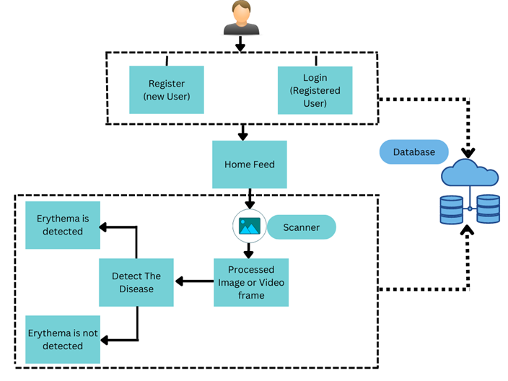

**5.2 Solution and Technical Architecture:**

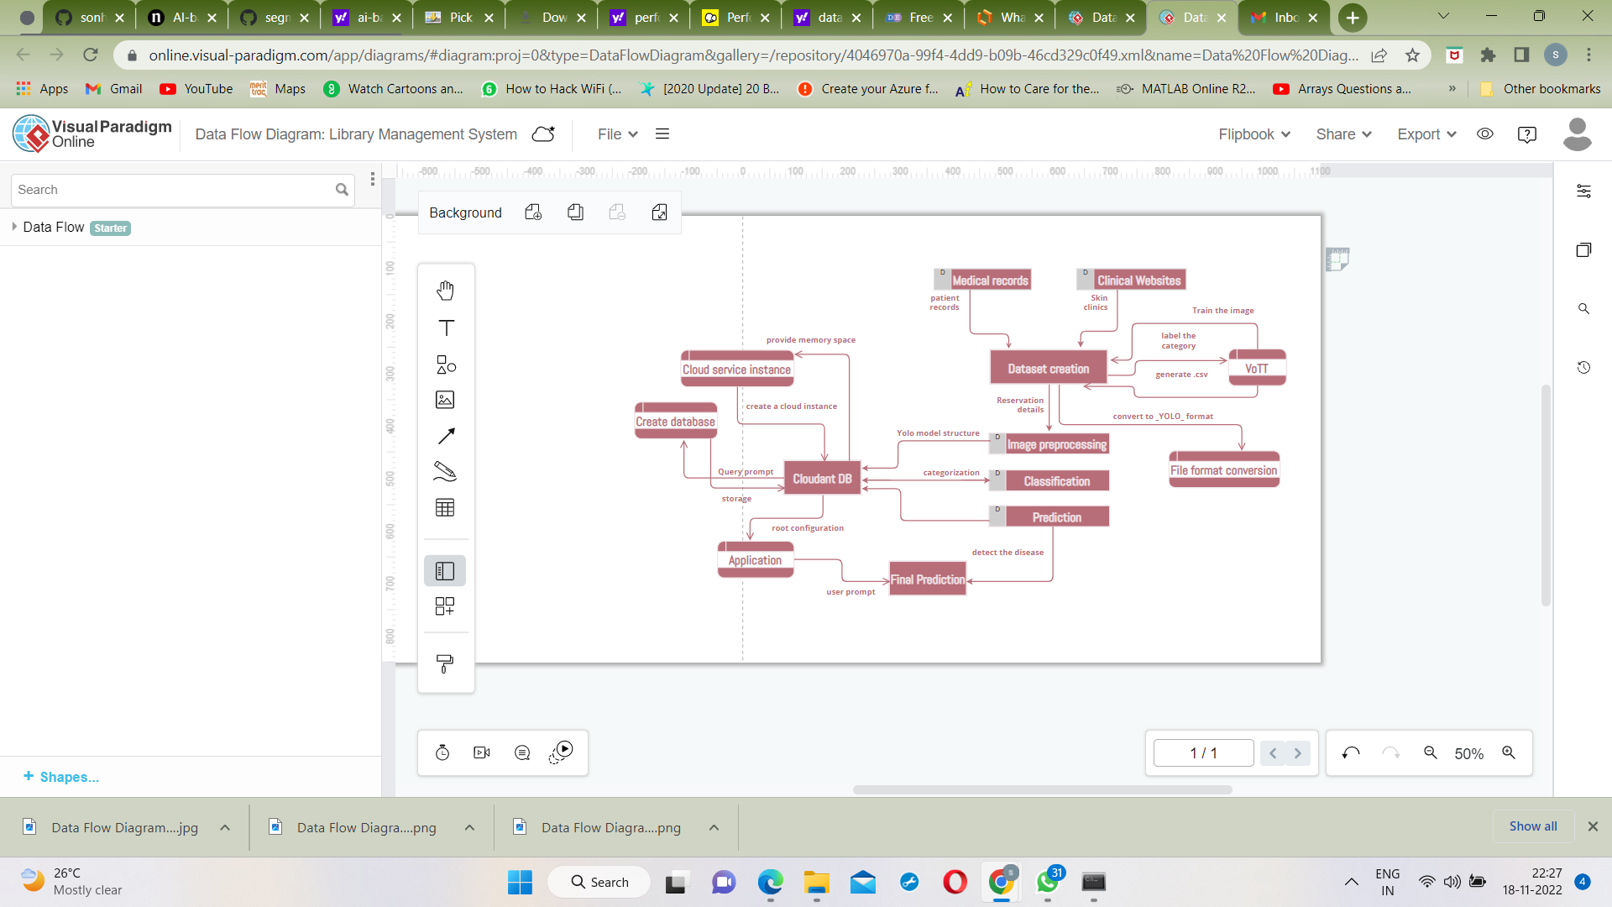

**5.3 User Stories:**

|  |  |  |  |  |  |  |  |
| --- | --- | --- | --- | --- | --- | --- | --- |
| **User Type** | **Functional Requirement (Epic)** | **User Story Number** | **User Story / Task** | **Acceptance criteria** | **Priority** |  | **Release** |
| Customer (Mobile user) | Registration | USN-1 | As a user, I can register for the application by entering my email, password, and confirming my password. | I can access my account / dashboard | High |  | Sprint-1 |
|  |  | USN-2 | As a user, I will receive confirmation email once I have registered for the application | I can receive confirmation email & click confirm | High |  | Sprint-1 |
|  |  | USN-3 | As a user, I can register for the application through Facebook | I can register & access the dashboard with Facebook Login | Low |  | Sprint-2 |
|  |  | USN-4 | As a user, I can register for the application through Gmail |  | Medium |  | Sprint-1 |
|  | Login | USN-5 | As a user, I can log into the application by entering email & password |  | High |  | Sprint-1 |
|  | Dashboard | USN-5 | As a user, I can Access my Dashboard |  | Medium |  | Sprint-3 |
| Customer (Web user) | Registration | USN-1 | As a user, I can register for the application by entering my email, password, and confirming my password. | I can access my account / dashboard | High |  | Sprint-4 |
| Customer Care Executive | Solution | USN-5 | Responding to each email you can receive | Offer a solution for how your company can improve the customer’s experience | High |  | Sprint-3 |
| Administrator | Manage | USN-5 | Do-it-yourself service for delivering everything | Set of predefined requirements that must be met to mark a user story complete. | High |  | Sprint-4 |

**6.PROJECT PLANNING AND SCHEDULING**

**6.1 Sprint Planning and Estimation:**

Sprints are the backbone of any good Agile development team. And the better prepared you are before a sprint, the more likely you are to hit your goals. Spring planning helps to refocus attention, minimize surprises, and guarantee better code gets shippied. Sprint planning aligns the development team with the product owner. You and your team requires communication and clarity and make sure that your expectations are understood and can be done by your team is key to keeping everyone motivated and productive.

Step 1: Review your product roadmap

Step 2: Groom your product backlog and update user stories

Step 3: Propose a sprint goal and backlog before the sprint planning meeting

Step 4: Use data and experience to supercharge your Sprint planning meeting

Step 5: Walk through each user story and describe what tasks need to be done

**6.2 Sprint Delivery Schedule:**

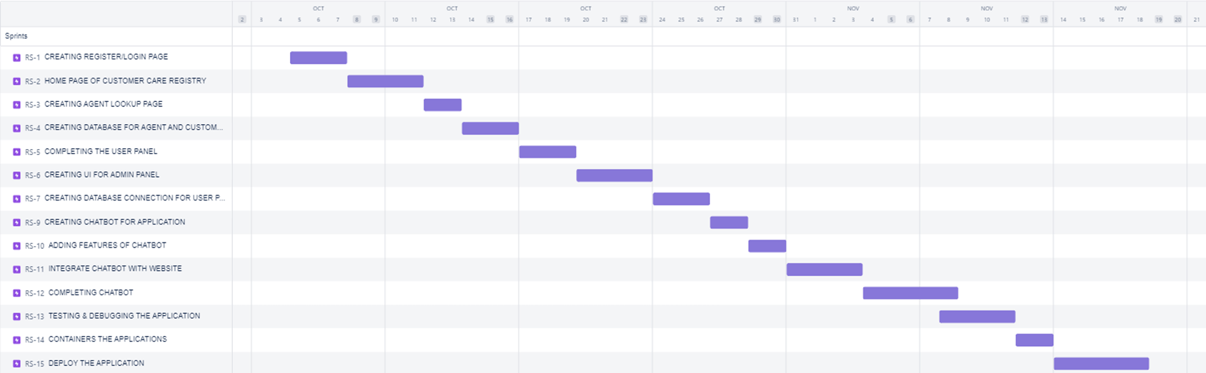**6.3 Reports from JIRA:**

Sprint 1:

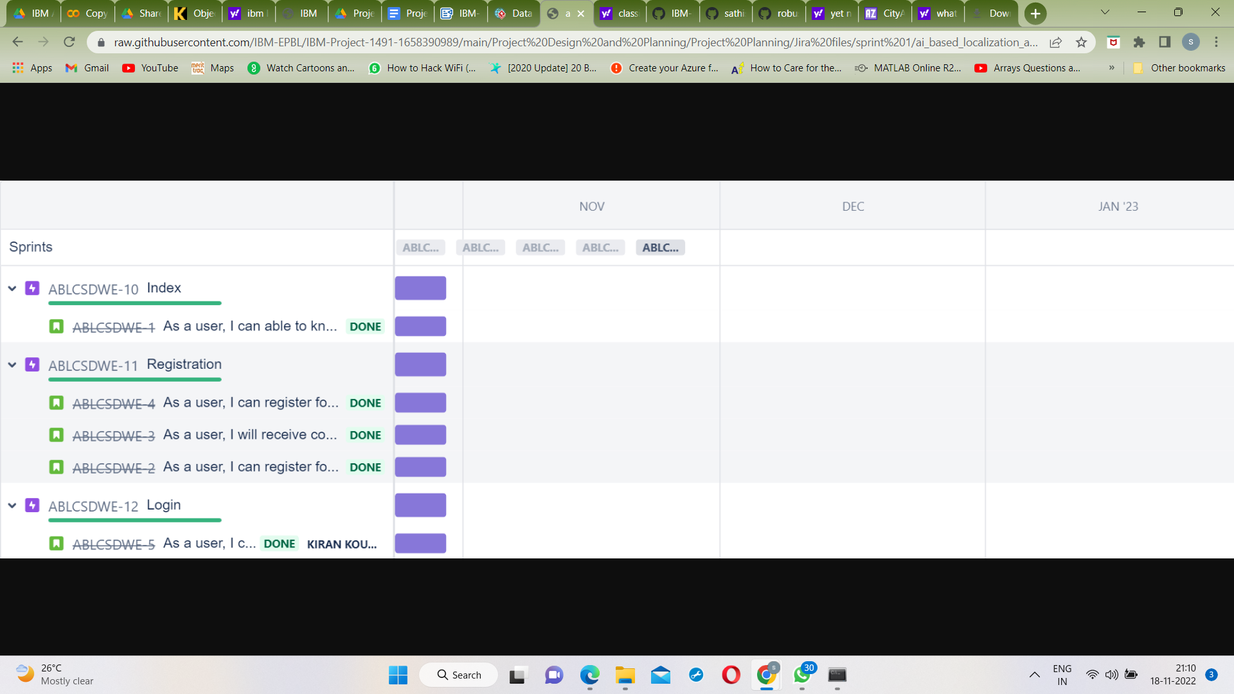

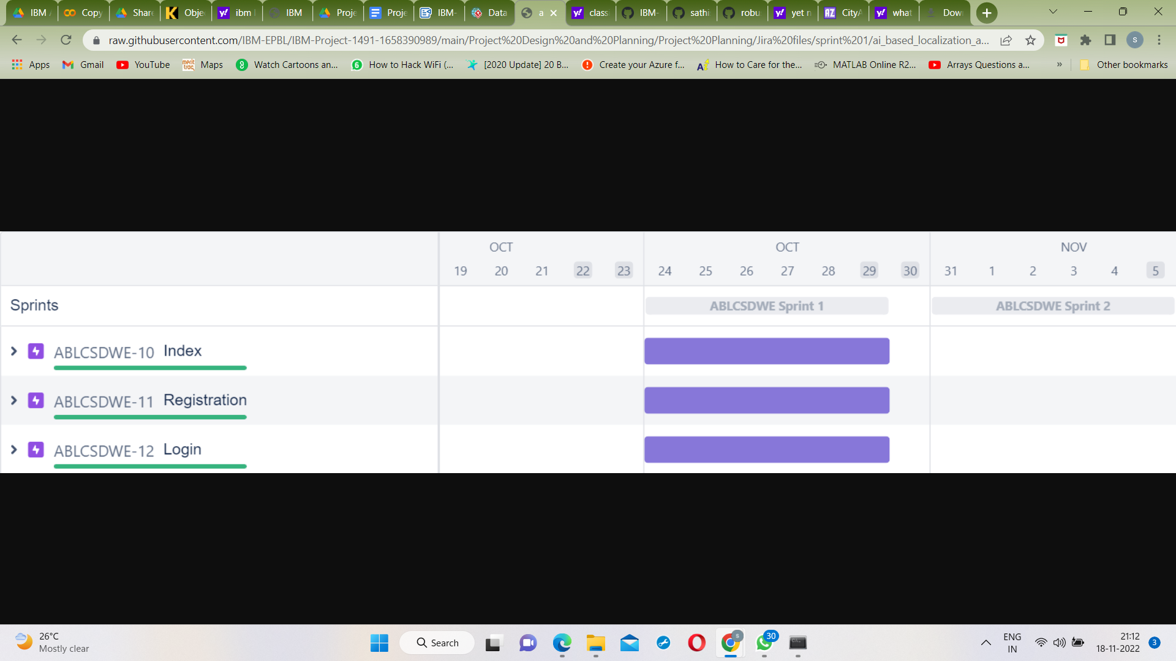

Sprint 2:

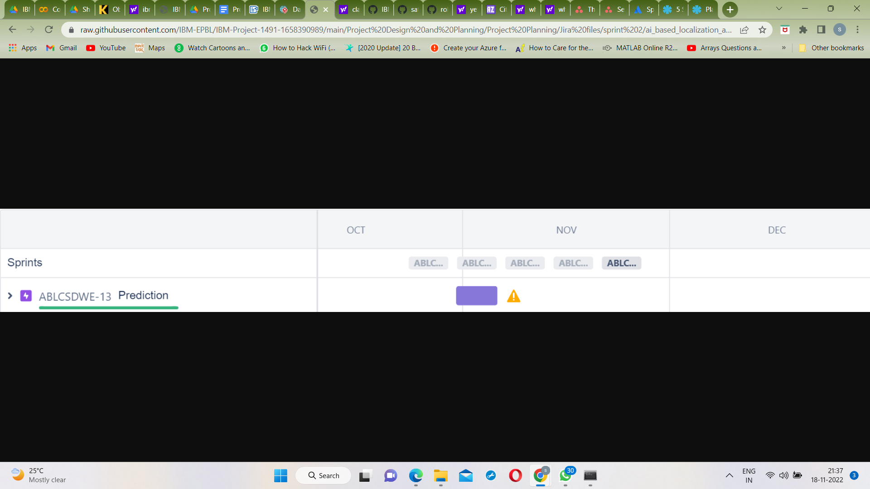

Sprint 3:

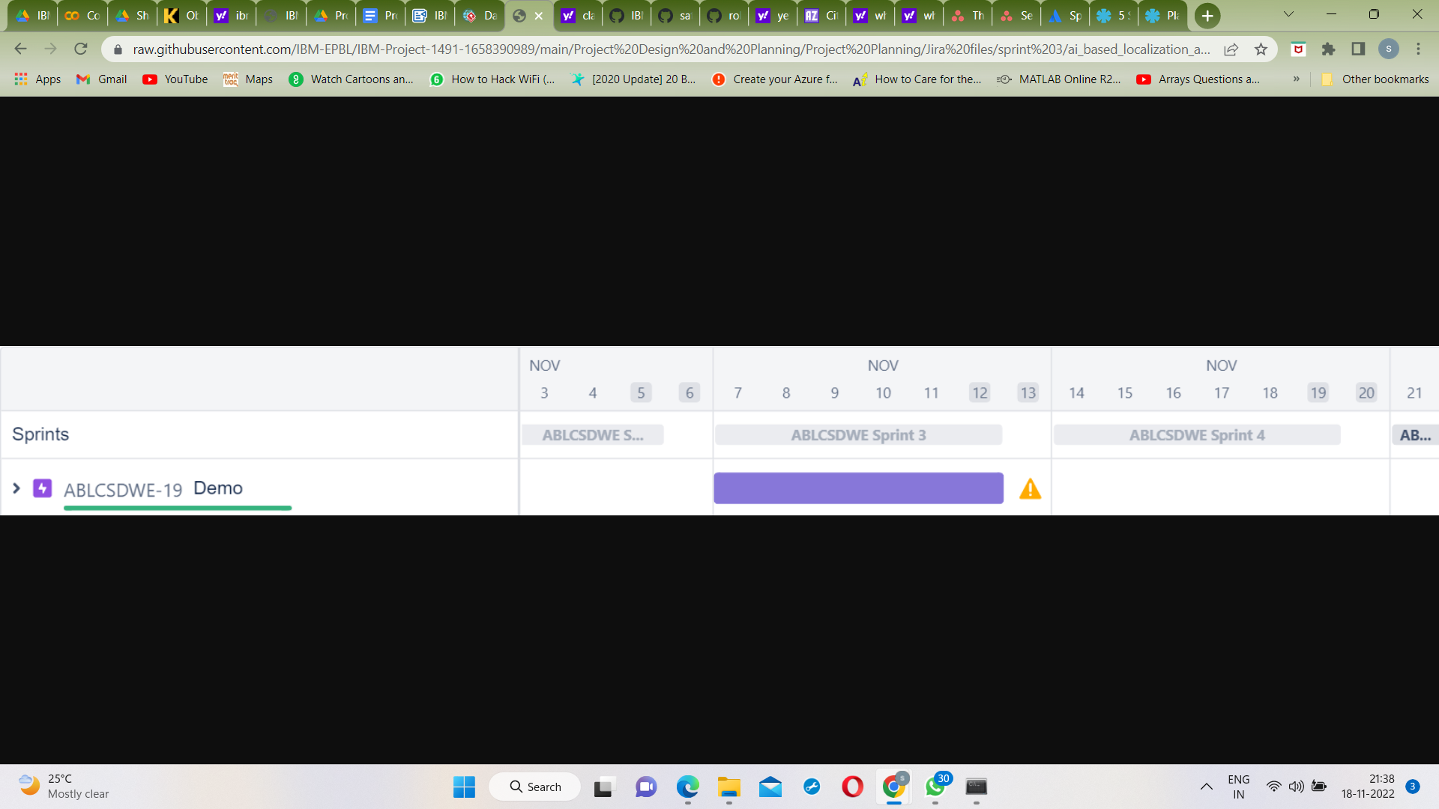

Sprint 4:

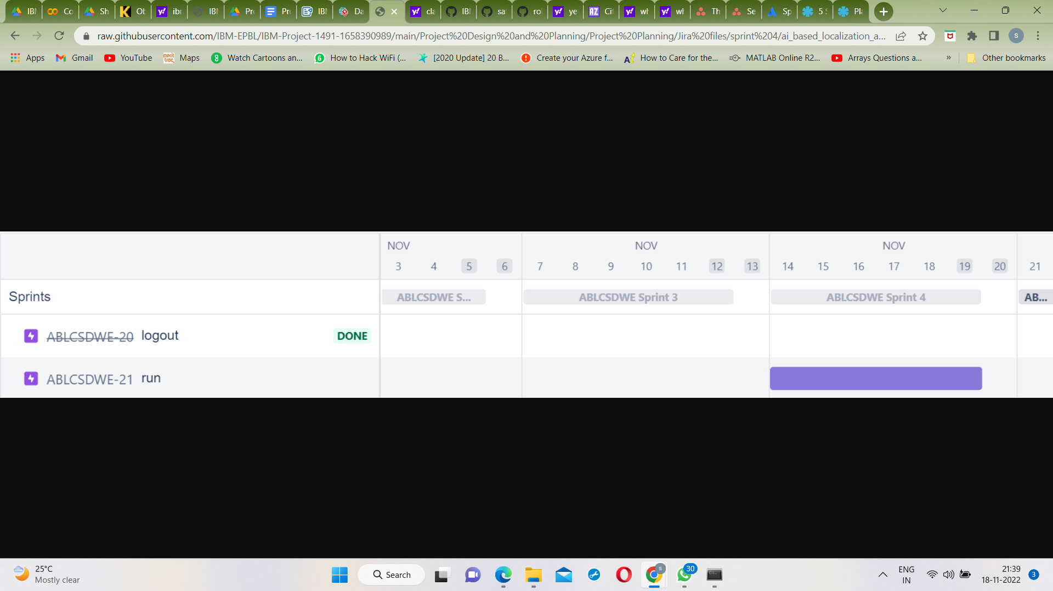

**7. CODING & SOLUTIONING**

**7.1 Microsoft's Visual Object Tagging Tool (VoTT):**

It is an open source annotation and labeling tool for image and video assets.

VoTT is a React + Redux Web application, written in [TypeScript](https://github.com/Microsoft/TypeScript).

Features include:

* The ability to label images or video frames
* Extensible model for importing data from local or cloud storage providers
* Extensible model for exporting labeled data to local or cloud storage providers

Using VoTT:

* Creating Connections
* Creating a New Project
  + - Project Settings
    - Security Tokens
* Labeling an Image
* Labeling a Video
* Exporting Labels

### 7.2 YOLO Project Structure:

It was proposed by Joseph Redmond et al. in 2015. It was proposed to deal with the problems faced by the object recognition models at that time, Fast R-CNN is one of the state-of-the-art models at that time but it has its own challenges such as this network cannot be used in real-time, because it takes 2-3 seconds to predicts an image and therefore cannot be used in real-time. Whereas, in YOLO we have to look only once in the network i.e. only one forward pass is required through the network to make the final predictions.

Code:

from PIL import Image

from os import path, makedirs

import os

import re

import pandas as pd

import sys

import argparse

from Convert_Format import convert_vott_csv_to_yolo

def get_parent_dir(n=1):

""" returns the n-th parent dicrectory of the current

working directory """

current_path = os.path.dirname(os.path.abspath(__file__))

for k in range(n):

current_path = os.path.dirname(current_path)

return current_path

sys.path.append(os.path.join(get_parent_dir(1), "Utils"))

Data_Folder = os.path.join(get_parent_dir(1), "Data")

VoTT_Folder = os.path.join(

Data_Folder, "Source_Images", "Training_Images", "vott-csv-export"

)

VoTT_csv = os.path.join(VoTT_Folder, "Annotations-export.csv")

YOLO_filename = os.path.join(VoTT_Folder, "data_train.txt")

model_folder = os.path.join(Data_Folder, "Model_Weights")

classes_filename = os.path.join(model_folder, "data_classes.txt")

if __name__ == "__main__":

# surpress any inhereted default values

parser = argparse.ArgumentParser(argument_default=argparse.SUPPRESS)

"""

Command line options

"""

parser.add_argument(

"--VoTT_Folder",

type=str,

default=VoTT_Folder,

help="Absolute path to the exported files from the image tagging step with VoTT. Default is "

+ VoTT_Folder,

)

parser.add_argument(

"--VoTT_csv",

type=str,

default=VoTT_csv,

help="Absolute path to the *.csv file exported from VoTT. Default is "

+ VoTT_csv,

)

parser.add_argument(

"--YOLO_filename",

type=str,

default=YOLO_filename,

help="Absolute path to the file where the annotations in YOLO format should be saved. Default is "

+ YOLO_filename,

)

FLAGS = parser.parse_args()

# Prepare the dataset for YOLO

multi_df = pd.read_csv(FLAGS.VoTT_csv)

labels = multi_df["label"].unique()

labeldict = dict(zip(labels, range(len(labels))))

multi_df.drop_duplicates(subset=None, keep="first", inplace=True)

train_path = FLAGS.VoTT_Folder

convert_vott_csv_to_yolo(

multi_df, labeldict, path=train_path, target_name=FLAGS.YOLO_filename

)

# Make classes file

file = open(classes_filename, "w")

# Sort Dict by Values

SortedLabelDict = sorted(labeldict.items(), key=lambda x: x[1])

for elem in SortedLabelDict:

file.write(elem[0] + "\n")

file.close()

**7.3 Database Schema:**

A database schema defines how data is organized within a relational database; this is inclusive of logical constraints such as, table names, fields, data types, and the relationships between these entities. Schemas commonly use visual representations to communicate the architecture of the database, becoming the foundation for an organization’s data management discipline.

A database schema is considered the “blueprint” of a database which describes how the data may relate to other tables or other data models. However, the schema does not actually contain data.

key benefits of database schemas include:

* **Access and security**: Database schema design helps organize data into separate entities, making it easier to share a single schema within another database.
* **Organization and communication:** Documentation of database schemas allow for more organization and better communication among internal stakeholders.
* **Integrity**: This organization and communication also helps to ensure data validity.

Code:

from cloundant.client import cloudant

client=Cloudant.iam('username','apikey','connect True')

my_database=client.create_database('my_database')

**8. TESTING**

**8.1 User Acceptance Testing:**

User acceptance testing, a testing methodology where the clients/end users involved in testing the product to validate the product against their requirements. It is performed at client location at developer's site.

For industry such as medicine or aviation industry, contract and regulatory compliance testing and operational acceptance testing is also carried out as part of user acceptance testing.

UAT is context dependent and the UAT plans are prepared based on the requirements and NOT mandatory to execute all kinds of user acceptance tests and even coordinated and contributed by testing team.

Acceptance criteria are defined on:

* Functional Correctness and Completeness
* Data Integrity
* Data Conversion
* Usability
* Performance
* Timeliness
* Confidentiality and Availability
* Installability and Upgradability
* Scalability
* Documentation

**9. RESULTS**

**9.1 Performance Metrics:**

the performance metrics used for evaluating a classification model:

* Accuracy - The overall accuracy of a model is simply the number of correct predictions divided by the total number of predictions.
* Precision and Recall - Precision measures how good the model is at correctly identifying the positive class. Recall tell us how good the model is at correctly predicting all the positive observations in the dataset.
* F1-score - The F1 score is the harmonic mean of precision and recall. The F1 score will give a number between 0 and 1.
* AUC-ROC - The AUC is the measurement of the entire two-dimensional area under the curve and The ROC (Receiver Operating Characteristics) curve is a plot of the performance of the model

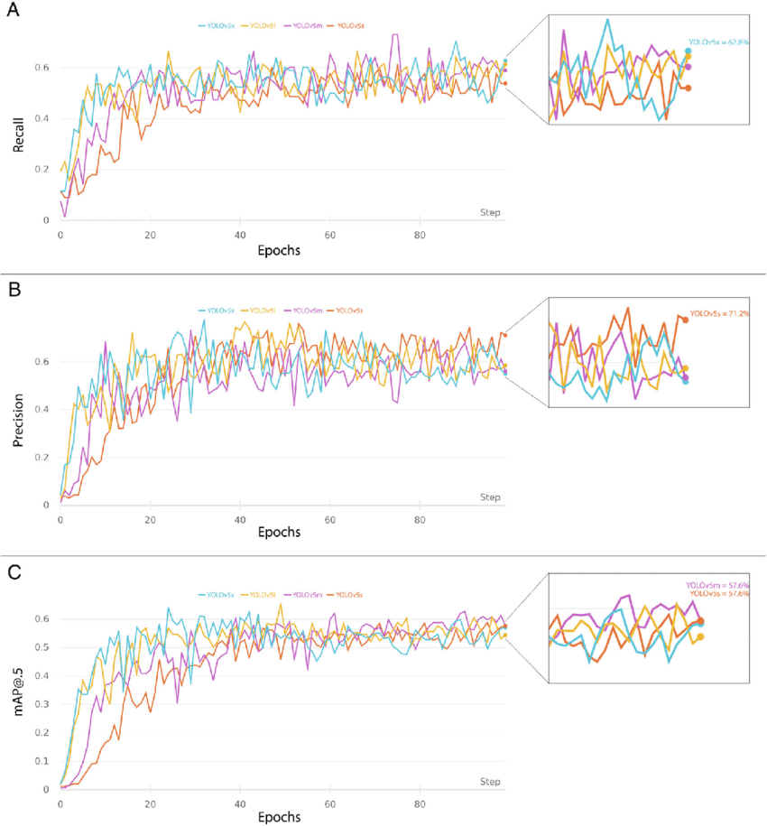

**10. ADVANTAGES & DISADVANTAGES**

**Merits:**

* In dermatology, although skin disease is a common disease, one in which early detection and classification is crucial for the successful treatment and recovery of patients, dermatologists perform most noninvasive screening tests only with the naked eye.
* This may result in avoidable diagnostic inaccuracies as a result of human error, as the detection of the disease can be easily overlooked.
* Therefore, it would be beneficial to exploit the strengths of CAD using artificial intelligence techniques, in order to improve the accuracy of dermatology diagnosis.

**Demerits:**

* An inherent disadvantage of clustering a skin disease is its lack of robustness against noise.
* Centroid that can generalize a cluster of data can significantly degrade the performance of these algorithms.
* the degradation problem that occurs when CNN models become too large and complex.
* Hence,We implement skip-connections in both segmentation and classification models.

**11. CONCLUSION**

The Project AI-Based Localization of Skin Disease With Erythema is used to find whether the person is having erythema or not. And our project helps lots of people to find whether their skin disease is erythema or not. Our website shows the accurate result so it helps the user to check their skin Disease. It is User Friendly Website.

**12. FUTURE SCOPE**

Future Scope of Our Project AI - Based Localization Of Skin Disease With Erythema is to try new algorthims and improve the accuracy of the result. And also developing a mobile application is our scope of the project

**13. APPENDIX**

Source Code:

Convert_csv_to_YOLO.py:

import os

import re

from os import makedirs, path

import numpy as np

import pandas as pd

from PIL import Image

from Get_File_Paths import ChangeToOtherMachine, GetFileList

def convert_vott_csv_to_yolo(

vott_df,

labeldict=dict(zip(["Cat_Face"], [0,])),

path="",

target_name="data_train.txt",

abs_path=False,

):

# Encode labels according to labeldict if code's don't exist

if not "code" in vott_df.columns:

vott_df["code"] = vott_df["label"].apply(lambda x: labeldict[x])

# Round float to ints

for col in vott_df[["xmin", "ymin", "xmax", "ymax"]]:

vott_df[col] = (vott_df[col]).apply(lambda x: round(x))

# Create Yolo Text file

last_image = ""

txt_file = ""

for index, row in vott_df.iterrows():

if not last_image == row["image"]:

if abs_path:

txt_file += "\n" + row["image_path"] + " "

else:

txt_file += "\n" + os.path.join(path, row["image"]) + " "

txt_file += ",".join(

[

str(x)

for x in (row[["xmin", "ymin", "xmax", "ymax", "code"]].tolist())

]

)

else:

txt_file += " "

txt_file += ",".join(

[

str(x)

for x in (row[["xmin", "ymin", "xmax", "ymax", "code"]].tolist())

]

)

last_image = row["image"]

file = open(target_name, "w")

file.write(txt_file[1:])

file.close()

return True

def csv_from_xml(directory, path_name=""):

# First get all images and xml files from path and its subfolders

image_paths = GetFileList(directory, ".jpg")

xml_paths = GetFileList(directory, ".xml")

result_df = pd.DataFrame()

if not len(image_paths) == len(xml_paths):

print("number of annotations doesnt match number of images")

return False

for image in image_paths:

target_filename = os.path.join(path_name, image) if path_name else image

source_filename = os.path.join(directory, image)

y_size, x_size, _ = np.array(Image.open(source_filename)).shape

source_xml = image.replace(".jpg", ".xml")

txt = open(source_xml, "r").read()

y_vals = re.findall(r"(?:x>\n)(.*)(?:\n</)", txt)

ymin_vals = y_vals[::2]

ymax_vals = y_vals[1::2]

x_vals = re.findall(r"(?:y>\n)(.*)(?:\n</)", txt)

xmin_vals = x_vals[::2]

xmax_vals = x_vals[1::2]

label_vals = re.findall(r"(?:label>\n)(.*)(?:\n</)", txt)

label_name_vals = re.findall(r"(?:labelname>\n)(.*)(?:\n</)", txt)

df = pd.DataFrame()

df["xmin"] = xmin_vals

df["xmin"] = df["xmin"].astype(float) * x_size

df["ymin"] = ymin_vals

df["ymin"] = df["ymin"].astype(float) * y_size

df["xmax"] = xmax_vals

df["xmax"] = df["xmax"].astype(float) * x_size

df["ymax"] = ymax_vals

df["ymax"] = df["ymax"].astype(float) * y_size

df["label"] = label_name_vals

df["code"] = label_vals

df["image_path"] = target_filename

df["image"] = os.path.basename(target_filename)

result_df = result_df.append(df)

# Bring image column first

cols = list(df.columns)

cols = [cols[-1]] + cols[:-1]

result_df = result_df[cols]

return result_df

def crop_and_save(

image_df,

target_path,

target_file,

one=True,

label_dict={0: "house"},

postfix="cropped",

):

"""Takes a vott_csv file with image names, labels and crop_boxes

and crops the images accordingly

Input csv file format:

image xmin ymin xmax ymax label

im.jpg 0 10 100 500 house

Parameters

----------

df : pd.Dataframe

The input dataframe with file_names, bounding box info

and label

source_path : str

Path of source images

target_path : str, optional

Path to save cropped images

one : boolean, optional

if True, only the most central house will be returned

Returns

-------

True if completed succesfully

"""

if not path.isdir(target_path):

makedirs(target_path)

previous_name = ""

counter = 0

image_df.dropna(inplace=True)

image_df["image_path"] = ChangeToOtherMachine(image_df["image_path"].values)

def find_rel_position(row):

current_name = row["image_path"]

x_size, _ = Image.open(current_name).size

x_centrality = abs((row["xmin"] + row["xmax"]) / 2 / x_size - 0.5)

return x_centrality

if one:

centrality = []

for index, row in image_df.iterrows():

centrality.append(find_rel_position(row))

image_df["x_centrality"] = pd.Series(centrality)

image_df.sort_values(["image", "x_centrality"], inplace=True)

image_df.drop_duplicates(subset="image", keep="first", inplace=True)

new_paths = []

for index, row in image_df.iterrows():

current_name = row["image_path"]

if current_name == previous_name:

counter += 1

else:

counter = 0

imageObject = Image.open(current_name)

cropped = imageObject.crop((row["xmin"], row["ymin"], row["xmax"], row["ymax"]))

label = row["label"]

if type(label) == int:

label = label_dict[label]

image_name_cropped = (

"_".join([row["image"][:-4], postfix, label, str(counter)]) + ".jpg"

)

new_path = os.path.join(target_path, image_name_cropped)

cropped.save(new_path)

new_paths.append(new_path.replace("\\", "/"))

previous_name = current_name

pd.DataFrame(new_paths, columns=["image_path"]).to_csv(target_file)

return True

if __name__ == "__main__":

# Prepare the houses dataset for YOLO

labeldict = dict(zip(["house"], [0,]))

multi_df = r"C:\Users\Admin\Desktop\yolo_structure\Data\Source_Images\Training_Images\vott-csv-export\Annotations-export.csv"

convert_vott_csv_to_yolo(

multi_df,

labeldict,

path=r"C:\Users\Admin\Desktop\data\skin",

target_name= "data_train.txt"

)

# Prepare the windows dataset for YOLO

path = r"C:\Users\Admin\Desktop\yolo_structure\Data\Source_Images\base"

csv_from_xml(path, r"C:\Users\Admin\Desktop\data\windows").to_csv(r"C:\Users\Admin\Desktop\yolo_structure\Data\Source_Images\base/annotations.csv")

label_names = [

"Erythema multiforme (EM)",

"Erythema chronicum migrans",

"Erythema migrans",

"Erythema marginatum",

"Erythema infectiosum",

"Erythema nodosum"

]

labeldict = dict(zip(label_names, list(range(6))))

convert_vott_csv_to_yolo(

csv_from_xml(path, r"C:\Users\Admin\Desktop\data\windows"), labeldict

)

Train YOLOv3 Detector:

import os

import sys

def get_parent_dir(n=1):

""" returns the n-th parent dicrectory of the current

working directory """

current_path = os.path.dirname(os.path.abspath(__file__))

for k in range(n):

current_path = os.path.dirname(current_path)

return current_path

src_path = os.path.join(get_parent_dir(1), "2_Training", "src")

utils_path = os.path.join(get_parent_dir(1), "Utils")

sys.path.append(src_path)

sys.path.append(utils_path)

import argparse

from keras_yolo3.yolo import YOLO, detect_video

from PIL import Image

from timeit import default_timer as timer

from utils import load_extractor_model, load_features, parse_input, detect_object

import test

import utils

import pandas as pd

import numpy as np

from Get_File_Paths import GetFileList

import random

os.environ["TF_CPP_MIN_LOG_LEVEL"] = "3"

# Set up folder names for default values

data_folder = os.path.join(get_parent_dir(n=1), "Data")

image_folder = os.path.join(data_folder, "Source_Images")

image_test_folder = os.path.join(image_folder, "Test_Images")

detection_results_folder = os.path.join(image_folder, "Test_Image_Detection_Results")

detection_results_file = os.path.join(detection_results_folder, "Detection_Results.csv")

model_folder = os.path.join(data_folder, "Model_Weights")

model_weights = os.path.join(model_folder, "trained_weights_final.h5")

model_classes = os.path.join(model_folder, "data_classes.txt")

anchors_path = os.path.join(src_path, "keras_yolo3", "model_data", "yolo_anchors.txt")

FLAGS = None

if __name__ == "__main__":

# Delete all default flags

parser = argparse.ArgumentParser(argument_default=argparse.SUPPRESS)

"""

Command line options

"""

parser.add_argument(

"--input_path",

type=str,

default=image_test_folder,

help="Path to image/video directory. All subdirectories will be included. Default is "

+ image_test_folder,

)

parser.add_argument(

"--output",

type=str,

default=detection_results_folder,

help="Output path for detection results. Default is "

+ detection_results_folder,

)

parser.add_argument(

"--no_save_img",

default=False,

action="store_true",

help="Only save bounding box coordinates but do not save output images with annotated boxes. Default is False.",

)

parser.add_argument(

"--file_types",

"--names-list",

nargs="*",

default=[],

help="Specify list of file types to include. Default is --file_types .jpg .jpeg .png .mp4",

)

parser.add_argument(

"--yolo_model",

type=str,

dest="model_path",

default=model_weights,

help="Path to pre-trained weight files. Default is " + model_weights,

)

parser.add_argument(

"--anchors",

type=str,

dest="anchors_path",

default=anchors_path,

help="Path to YOLO anchors. Default is " + anchors_path,

)

parser.add_argument(

"--classes",

type=str,

dest="classes_path",

default=model_classes,

help="Path to YOLO class specifications. Default is " + model_classes,

)

parser.add_argument(

"--gpu_num", type=int, default=1, help="Number of GPU to use. Default is 1"

)

parser.add_argument(

"--confidence",

type=float,

dest="score",

default=0.25,

help="Threshold for YOLO object confidence score to show predictions. Default is 0.25.",

)

parser.add_argument(

"--box_file",

type=str,

dest="box",

default=detection_results_file,

help="File to save bounding box results to. Default is "

+ detection_results_file,

)

parser.add_argument(

"--postfix",

type=str,

dest="postfix",

default="_disease",

help='Specify the postfix for images with bounding boxes. Default is "_disease"',

)

FLAGS = parser.parse_args()

save_img = not FLAGS.no_save_img

file_types = FLAGS.file_types

if file_types:

input_paths = GetFileList(FLAGS.input_path, endings=file_types)

else:

input_paths = GetFileList(FLAGS.input_path)

# Split images and videos

img_endings = (".jpg", ".jpeg", ".png")

vid_endings = (".mp4", ".mpeg", ".mpg", ".avi")

input_image_paths = []

input_video_paths = []

for item in input_paths:

if item.endswith(img_endings):

input_image_paths.append(item)

elif item.endswith(vid_endings):

input_video_paths.append(item)

output_path = FLAGS.output

if not os.path.exists(output_path):

os.makedirs(output_path)

# define YOLO detector

yolo = YOLO(

**{

"model_path": FLAGS.model_path,

"anchors_path": FLAGS.anchors_path,

"classes_path": FLAGS.classes_path,

"score": FLAGS.score,

"gpu_num": FLAGS.gpu_num,

"model_image_size": (416, 416),

}

)

# Make a dataframe for the prediction outputs

out_df = pd.DataFrame(

columns=[

"image",

"image_path",

"xmin",

"ymin",

"xmax",

"ymax",

"label",

"confidence",

"x_size",

"y_size",

]

)

# labels to draw on images

class_file = open(FLAGS.classes_path, "r")

input_labels = [line.rstrip("\n") for line in class_file.readlines()]

print("Found {} input labels: {} ...".format(len(input_labels), input_labels))

if input_image_paths:

print(

"Found {} input images: {} ...".format(

len(input_image_paths),

[os.path.basename(f) for f in input_image_paths[:5]],

)

)

start = timer()

text_out = ""

# This is for images

for i, img_path in enumerate(input_image_paths):

print(img_path)

prediction, image,lat,lon= detect_object(

yolo,

img_path,

save_img=save_img,

save_img_path=FLAGS.output,

postfix=FLAGS.postfix,

)

print(lat,lon)

y_size, x_size, _ = np.array(image).shape

for single_prediction in prediction:

out_df = out_df.append(

pd.DataFrame(

[

[

os.path.basename(img_path.rstrip("\n")),

img_path.rstrip("\n"),

]

+ single_prediction

+ [x_size, y_size]

],

columns=[

"image",

"image_path",

"xmin",

"ymin",

"xmax",

"ymax",

"label",

"confidence",

"x_size",

"y_size",

],

)

)

end = timer()

print(

"Processed {} images in {:.1f}sec - {:.1f}FPS".format(

len(input_image_paths),

end - start,

len(input_image_paths) / (end - start),

)

)

out_df.to_csv(FLAGS.box, index=False)

# This is for videos

if input_video_paths:

print(

"Found {} input videos: {} ...".format(

len(input_video_paths),

[os.path.basename(f) for f in input_video_paths[:5]],

)

)

start = timer()

for i, vid_path in enumerate(input_video_paths):

output_path = os.path.join(

FLAGS.output,

os.path.basename(vid_path).replace(".", FLAGS.postfix + "."),

)

detect_video(yolo, vid_path, output_path=output_path)

end = timer()

print(

"Processed {} videos in {:.1f}sec".format(

len(input_video_paths), end - start

)

)

# Close the current yolo session

yolo.close_session()

GitHub:

gh repo clone IBM-EPBL/IBM-Project-5510-1658769141

Project Demo Link:

https://drive.google.com/file/d/1-D08VKkBEN4U0HSD3wD0j406GURgmOEV/view?usp=sharing